Week 8

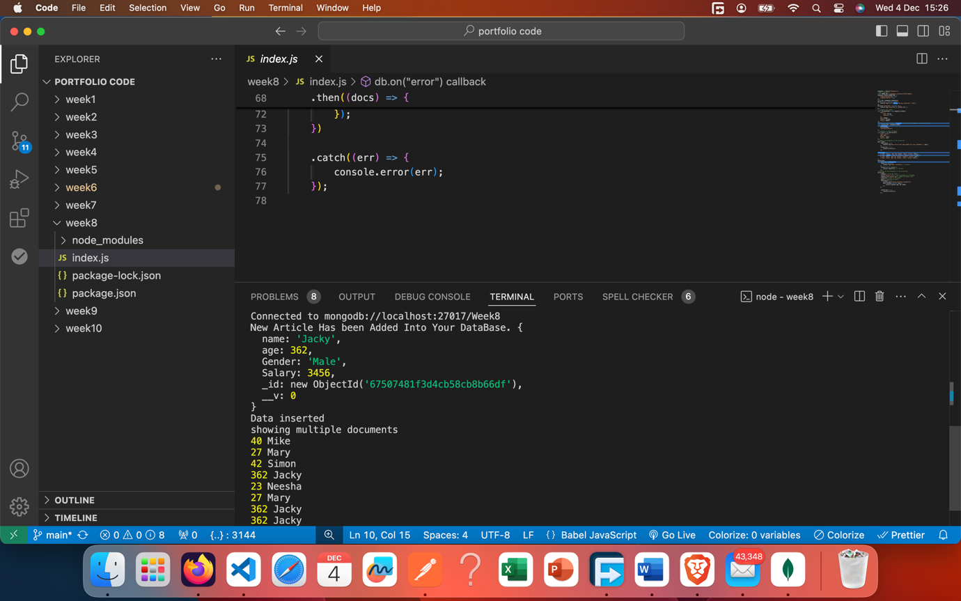

**Include the Uploaded Code in Your Portfolio**

* Upload the entire script to a public repository on GitHub, GitLab, or a similar platform.
* Provide a link to the repository in your portfolio.
* Ensure the repository includes:
  + A descriptive README.md file explaining the purpose of the code.
  + Detailed usage instructions.

**2. Explain the Functions**

* **Break down the code into its components.** Identify all the significant functions, such as save, find, or any others implemented in the code.
* **For each function:**
  + **Name of the function:** e.g., save()
  + **Purpose:** Explain what the function is designed to achieve.
  + **Parameters:** Describe the inputs the function takes (if any).
  + **Logic:** Provide a high-level overview of how the function works.
  + **Output:** Describe the result the function produces.

**3. Enhance with Visual Examples**

* **Screenshots:** Take screenshots of the code in action, such as:
  + Console outputs.
  + Application interfaces.
  + Debugging or runtime messages.
* **Diagrams:** If applicable, include flowcharts or diagrams to explain complex logic.

**4. Sample Structure for the Portfolio Entry**

**Project Title**: [Name of the Project]

**Description**:

* Provide a brief overview of what the script does and its intended purpose.

**Link to Code**: [Insert the link to your code repository]

**Code Highlights**:

* Outline the main features of the code.

**Functionality**:

* **Function Name:** save()
  + **Purpose:** Save data into the database or storage system.
  + **Parameters:** Takes a data object as input.
  + **Logic:** Parses the data and stores it in the relevant structure.
  + **Output:** Confirms whether the save operation was successful.
* **Function Name:** find()
  + **Purpose:** Retrieve data based on specific criteria.
  + **Parameters:** Takes a query object as input.
  + **Logic:** Searches through the dataset to match the query.
  + **Output:** Returns the matching results or an empty set.

*(Repeat for all key functions)*

**Illustrations**:

* [Insert screenshots of the code or application in use]
* [Insert any relevant diagrams or visual aids]

**Challenges & Solutions**:

* Discuss any challenges encountered during development and how they were resolved.

**Lessons Learned**:

* Summarize what you learned from this project.

**5. Technical Summary**

* Mention the technologies used (e.g., JavaScript, Node.js, etc.).
* Highlight the significance of the approach or methodology.